**The Garden Club Federation of Massachusetts**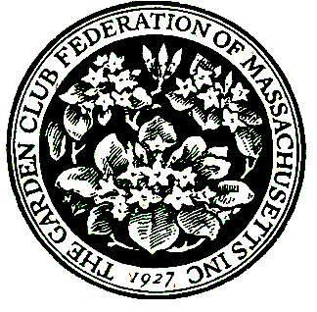

**400 Fifth Ave., Suite 110, Waltham, MA 02451**

**781-237-0336**

**GCFMStateAwards@gmail.com**

**APPLICATION FOR STATE AWARD for Calendar year 2024 Submissions due December 1, 2024**

Exceptions: Not for Flower Show achievement awards, Special Awards, or Civic Development and Historic Preservation Grants

The application consists of 2 Sections:

Section 1 – cover sheet, submitter, and club information

Section 2 – narrative responses for topics 1 – 6

**Section 1 - COVER SHEET**

* Please review these instructions before submitting your application.
* If you have questions or need assistance, please email the Awards Chair at [**GCFMStateAwards@gmail.com**](mailto:GCFMStateAwards@gmail.com)
* Refer to the [GCFM webpage](https://www.gcfm.org/) Awards tab for the Rules for State Awards

for descriptions and additional information.

* Application narrative is limited to three pages – front of pages only.
* Application and supporting material will not be returned.
* Awards year is January 1 – December 31.
* Do not submit an exact duplicate application for more than one award.
* Copy your entry for your files.
* All entries should be sent electronically as a PDF or Word document.
* **Email completed application to** [**GCFMStateAwards@gmail.com**](mailto:GCFMStateAwards@gmail.com)

to arrive by 11:59 PM on December 1.

**Section 1 - SUBMITTER AND CLUB INFORMATION SHEET**

**For all applications:**

Name of State Garden Club: Garden Club Federation of Massachusetts

Number in State Garden Club: 10,891 members 167 Clubs

State Awards Chair: Lisa Murray

Phone: 978-302-1063

Email: gcfmstateawards@gmail.com



**For your submission, complete the following items:**

Award #:

Award Name:

Today’s Date:

Your Name :

Phone:

E-mail:

Club President :

Phone:

E-mail:

Club name:

[Enter name exactly as it should appear on any award received]

Town:

Number of members in club: [please use number from GCFM 24-25 Directory]



**Section 2 - NARRATIVE: Complete topics 1 to 6, not to exceed 3 pages total.** **Use the numbering below to complete your application.**

1. New project: Yes____ OR continuing from previous work: Yes ____

Beginning date Expected completion date

OR Ongoing

2. Summary and objectives of project

3. Involvement of club members, other organizations, etc.

4. Project expenses and means of funding

5. Continuing involvement, follow-up, maintenance

6. Attach or insert photos, digital photos, and/or landscape plan

(does not need to be professionally drawn)